Chapter 5, Solution 13.

i_{o}
+
−
50 kΩ
+
v_{o}
−
10 kΩ
100 kΩ
1 V

+
−
a
b
10 kΩ
90 kΩ
i₂
i₁

By voltage division,

v_{a} = 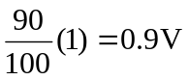

v_{b} = 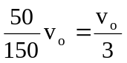

But v_{a} = v_{b} 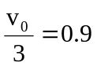 v_{o} = 2.7V

i_{o} = i₁ + i₂ = 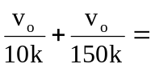 0.27mA + 0.018mA = 288 μA

